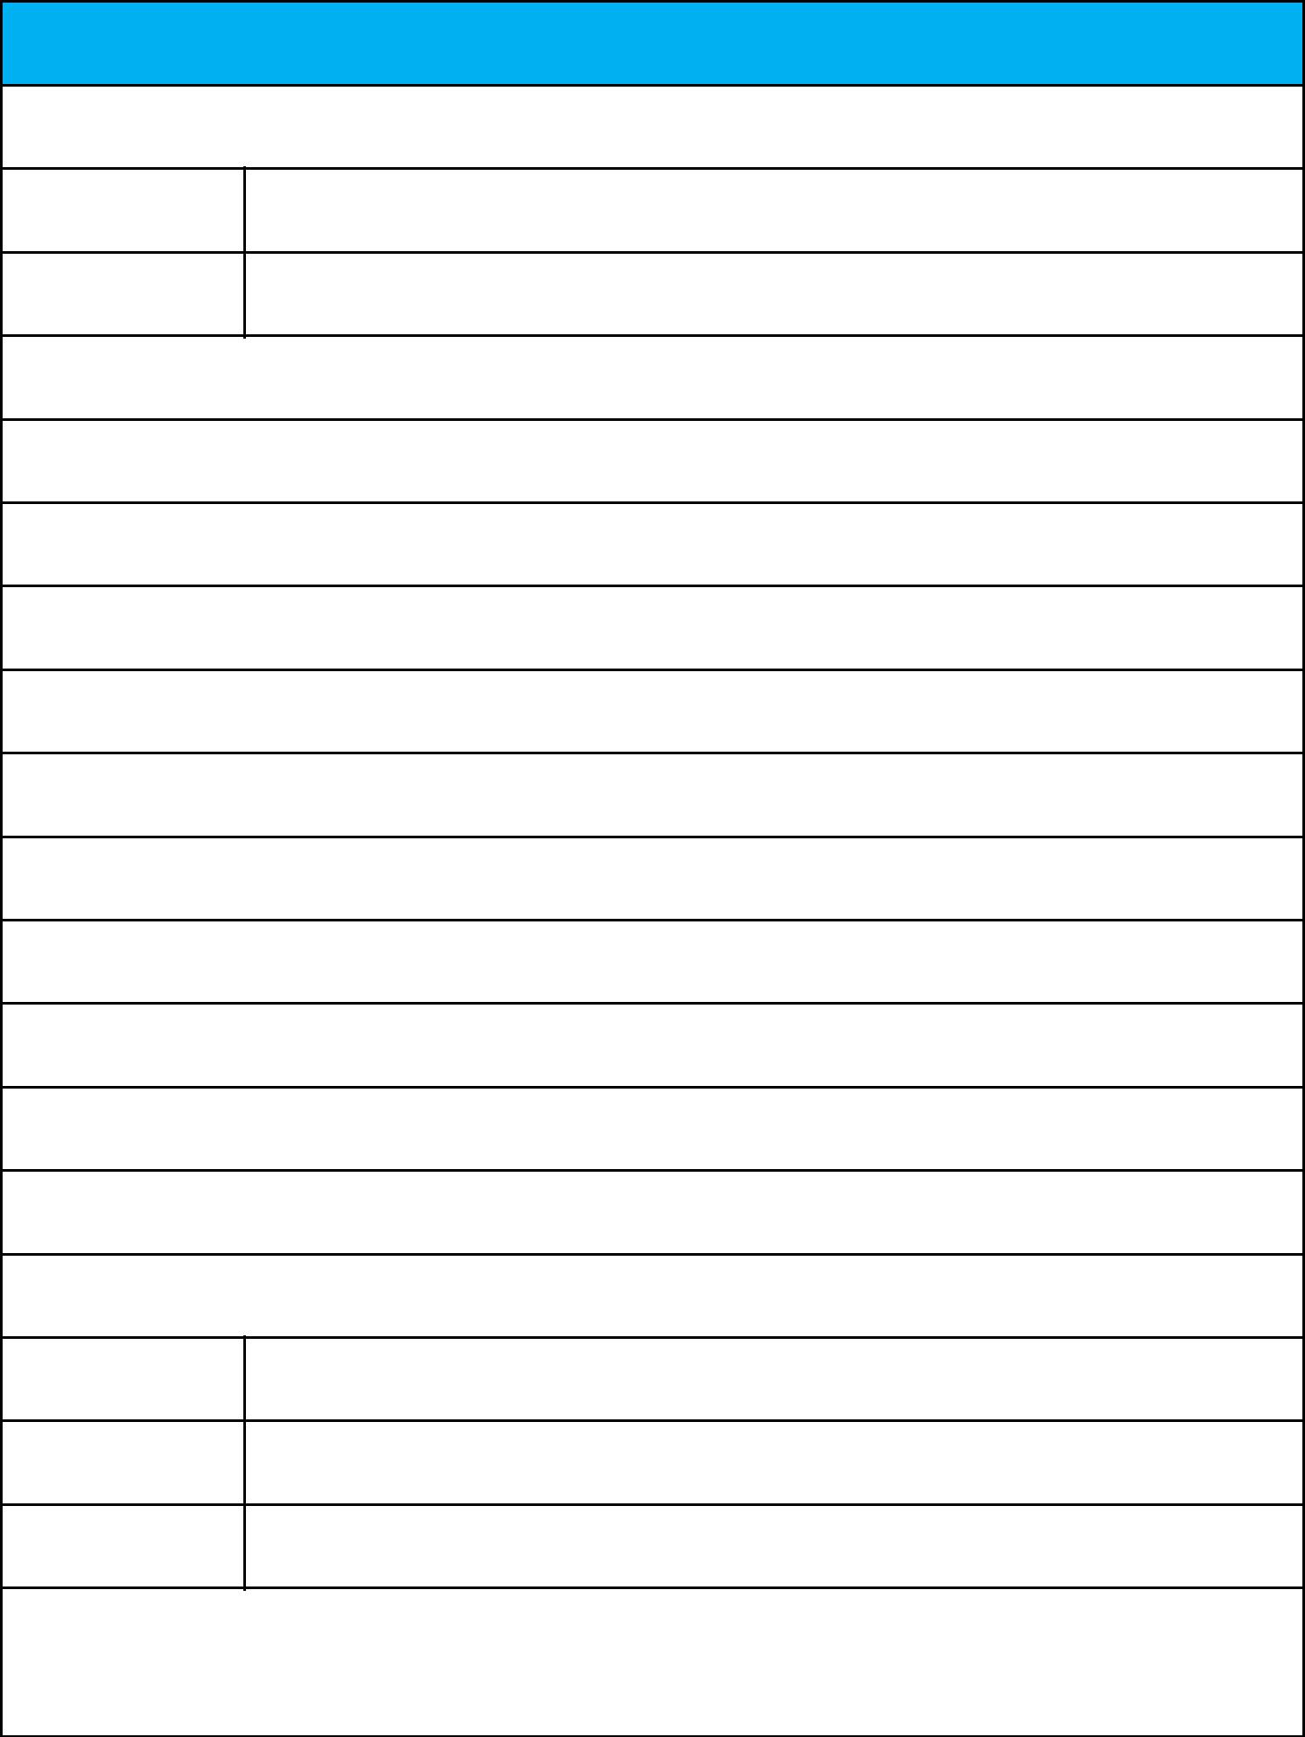**Rent Receipt Template**

**1. Employee details**

Employee ID 40027321

Full Name Pandravada Sri Venkata Rajaram Akhil

**2. Address of the rented house**

I Block – 406, Novus Florence Village Apartments, Gangavaram Port Road.Gajuwaka

CITY: Visakhapatnam

STATE: Andhra Pradesh PIN CODE:530044

**3. Rent details**

Received with thanks from (employee name) Mr./Ms. Pandravada Sri Venkata Rajaram Akhil

sum of Rs. 40800

(Rupees Forty Thousand and Eight Hundred only)

towards the rent of the above-mentioned residential premises for the month of 04/2022 – 06/2022

Mode of Payment (Cash/Cheque/Online): Online Payment Dated: 02-04-2022

**4. Landlord Details**

AVTPK4979L

Permanent account

number (PAN)

Full Name kommu lydia grace

Landlord Signature

kommu lydia grace 26-12-2022

and Date

**Note:** The HRA tax benefit is applicable only for the amount paid towards rent. Payment towards otherexpenses like maintenance, water, electricity, food, security deposits, late payment charges etc. are excluded. If other expenses are being paid along with the rent, the rent receipt should contain a break-up of all the components paid.